# Homework: Operating Systems

Problems for homework for the ["Software Technologies" course @ Software University.](https://softuni.bg/trainings/4383/software-technologies-january-2024)  
Submit this document as your homework.

## Work with Task Manager in Windows

1. **View processes:**
   * Open Task Manager and view the list of running processes.
   * Identify any processes that are using a high amount of CPU or RAM.

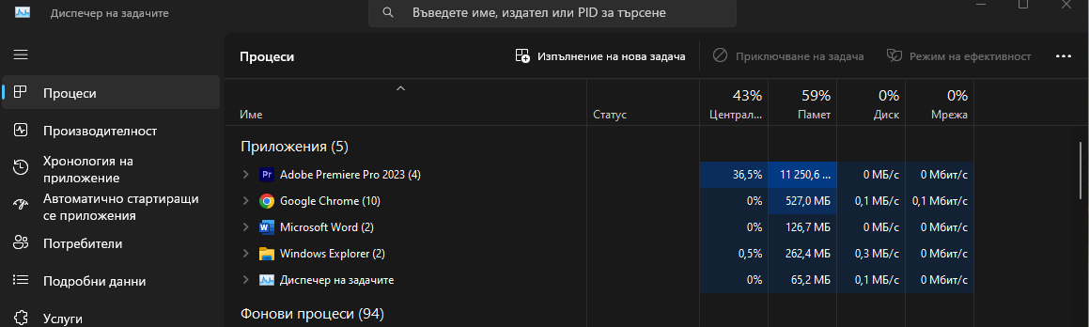

1. **Kill a process:**
   * Select a process from the list and end the task.

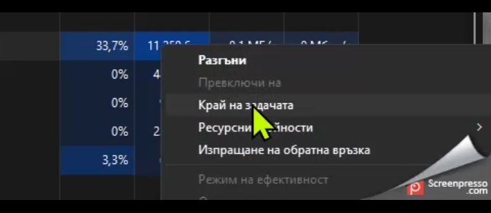

1. **View CPU & RAM usage:**
   * Navigate to the Performance tab in Task Manager and view the CPU & Memory usage.

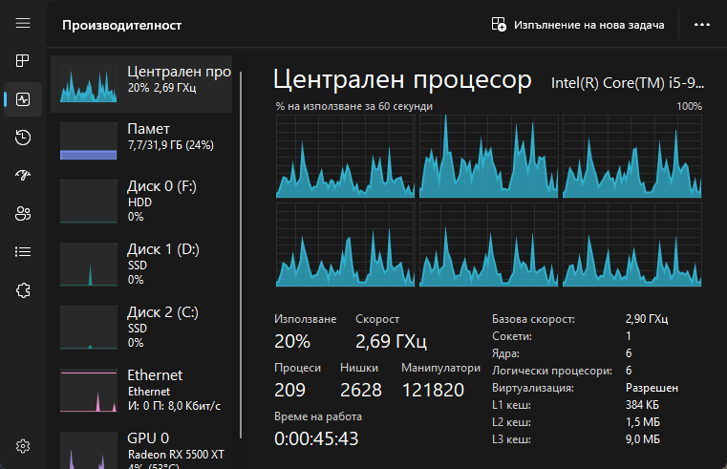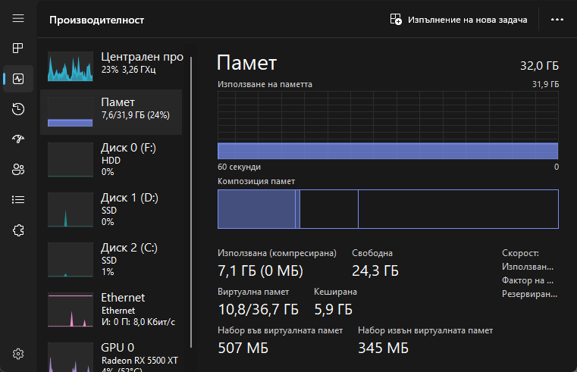

* **Replace all pictures with screenshots from your PC.**

## Play with Windows Terminal

1. **Navigate Directories:**
   * Use the "**cd**" command to navigate to different directories in the Windows Terminal:
     + Desktop
     + Documents
     + Downloads
   * Example (make screenshots of all three directories):



* + Create folder named My mkdir_SoftUni_Repo on the Desktop through the Terminal.
  + Example:

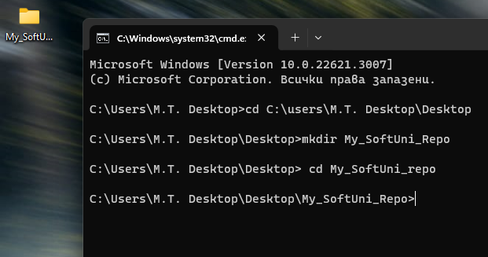

* + Enter the created folder through the Terminal and make a screenshot:

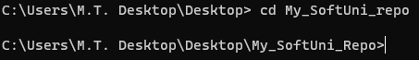

* **Replace all pictures with screenshots from your PC.**

## Play with Docker Playground & Run a Linux Shell inside

1. **Run your own container in Docker Playground and make an HTTP request from Linux Shell:**
   * Your task is to run a new docker container and make an HTTP request to the following API: [**https://api.zippopotam.us/**](https://api.zippopotam.us/)
   * Extend the URL with "**de**" for Germany, and find a valid postal code that you can use to extract information from the API.
   * Replace the example images with your own screenshots.
   * Examples:

